幼小班生字“水”學習單

NAME Date No
人 | 水 | 五 | 水

- 連連看match and coloring the picture

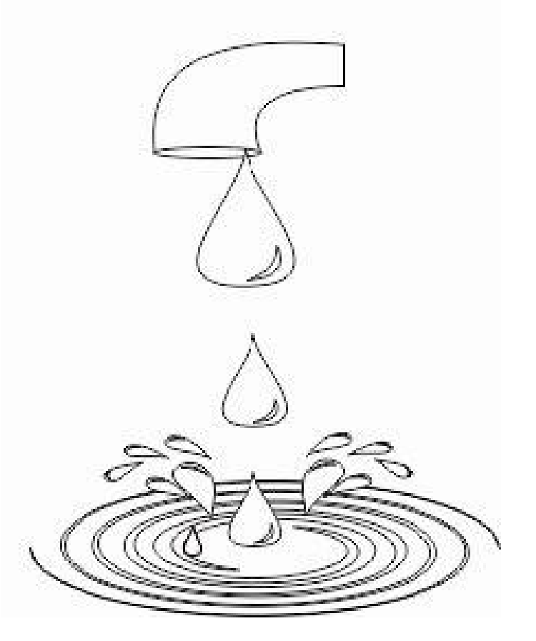

水 | 耳 | 水 | 四

