紐約慈濟人文學校 幼小信班 <大愛> 人文課學習單
姓名：

想一想，回答問題，把你的答案圖上顏色。Think and Answer Questions. Color the answer you have.

- 你拿回家的竹筒可以做什麼？ What can you do with the Bamboo Bank you bring home?
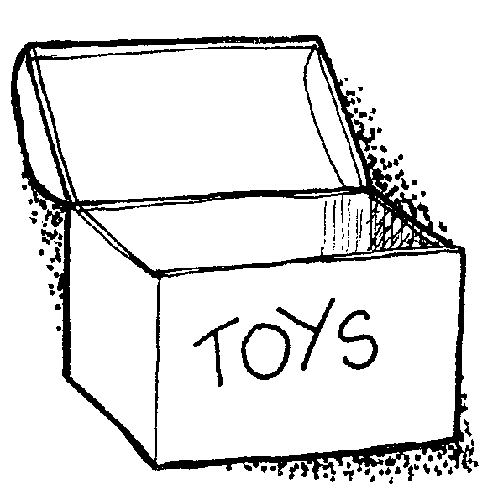 | 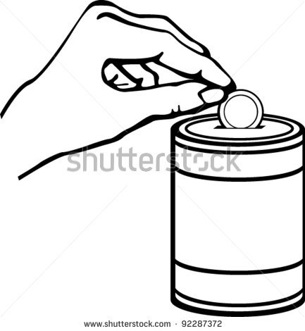 | 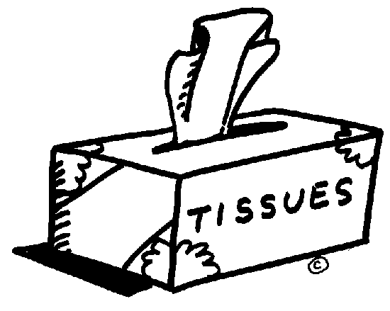 | 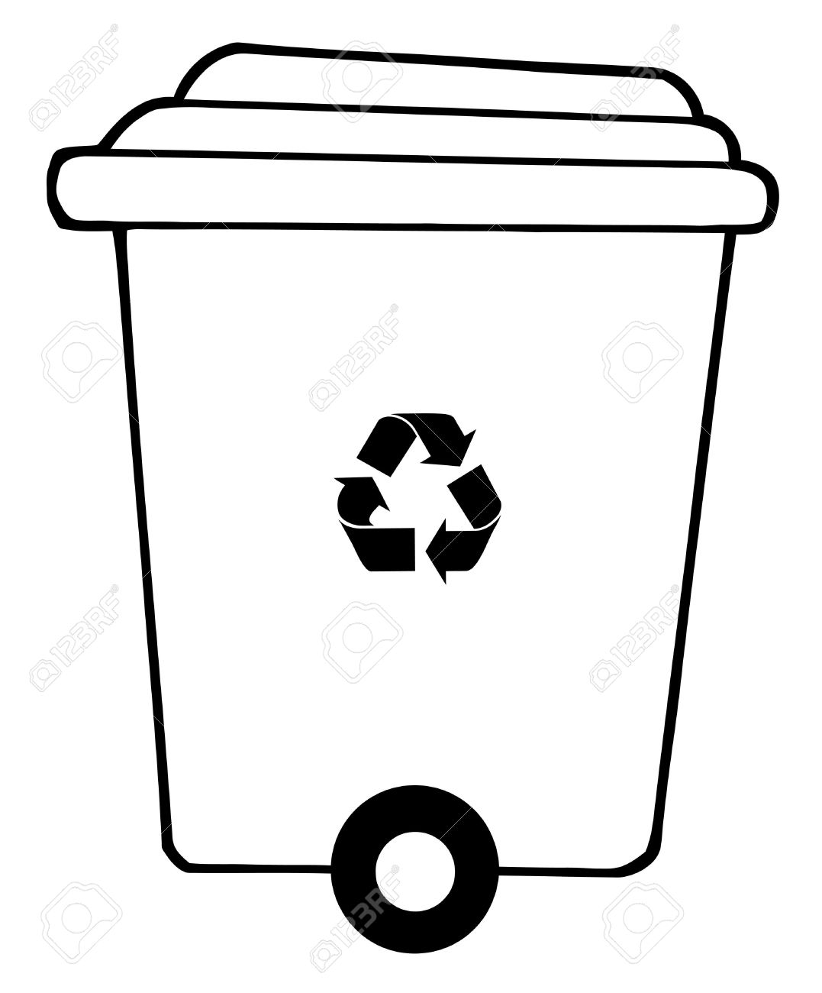

- 竹筒存的錢，你可以做什麼？ What would you like to use money in the Bamboo bank for?
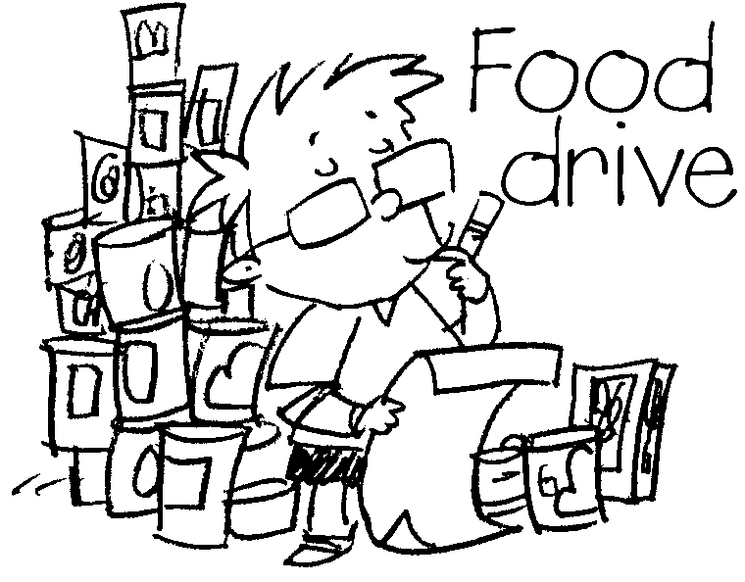  捐給慈善機構  Donate to the organization and help people who need. | 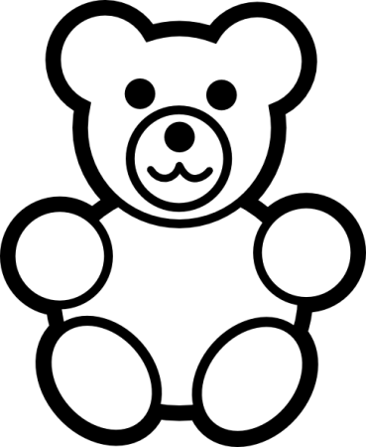  買自己想要的玩具  Buy the toy I want.
用在我想玩的遊戲  Spend on the game I want to play. | 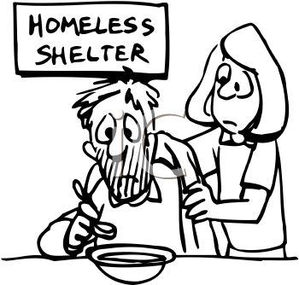  幇助需要幫助的人  Help people who need.

