幼小班學習單
Name: Date: No:
下面哪些東西會造成火災和燙傷？
What cause fire and burn?
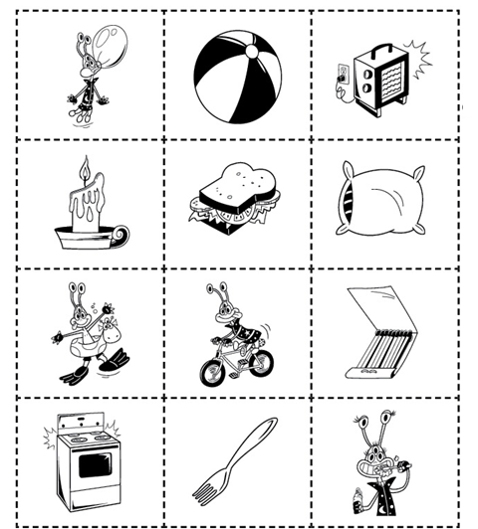
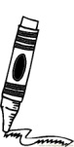 圖一圖顏色。Color it.

