幼小班中文字學習單
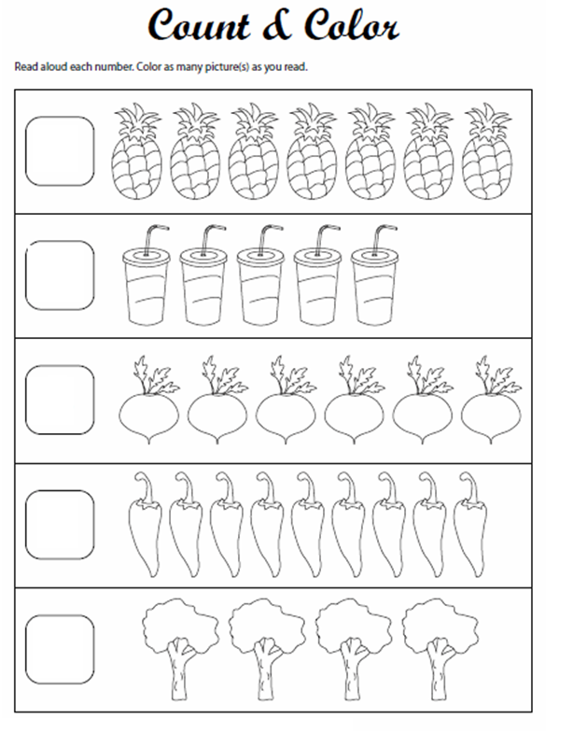
No: NAME: DATE:
五
三
四
一
二

