幼小信班五官學習單

Name: . DATE: .

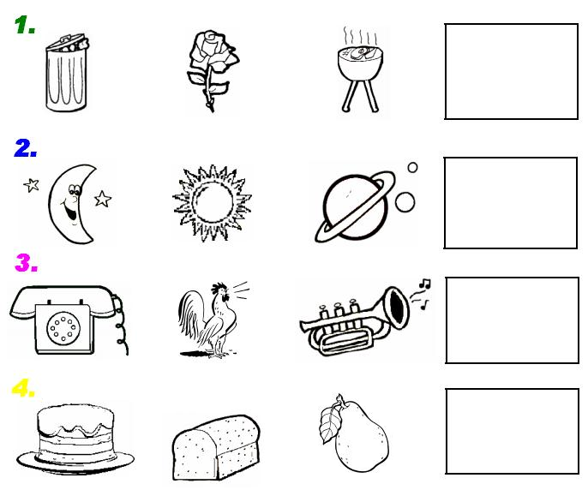剪一剪、貼一貼、塗一塗cut ,paste, and color

http://www.clker.com/cliparts/B/e/v/X/J/I/totetude-nose-outline-th.png